|  |
| --- |
| Name:H J K I Wijerama |
| Student Reference Number:10707417 |



|  |  |  |
| --- | --- | --- |
| Module Code: ISAD254SL | Module Name: Human Computer Interaction | |
| Coursework class activity | | |
| Deadline Date:  16 / 03/ 2021 | | Member of staff responsible for coursework:  Ms.pavithra Kankanamge |
| Programme: BSc(Hons)Software Engineering | | |
| Please note that University Academic Regulations are available under Rules and Regulations on the University website [www.plymouth.ac.uk/studenthandbook](http://www.plymouth.ac.uk/studenthandbook). | | |
| Group work: please list all names of all participants formally associated with this work and state whether the work was undertaken alone or as part of a team. Please note you may be required to identify individual responsibility for component parts.   * 10707417-H.J.K.Isindu Wijerama * 10707129-K.L.Dulani Anupama * 10707216-K.Charuka Heshan * 10713401-U.R.K.Ukwatta * 10707256 - N.N.D.G.Liyanage * 10707274 - P.Y.S.D.S.Manawadu   ***We confirm that we have read and understood the Plymouth University regulations relating to Assessment Offences and that we are aware of the possible penalties for any breach of these regulations. We confirm that this is the independent work of the group.***  Signed on behalf of the group:  nn  H.J.K.I. Wijerama | | |

|  |
| --- |
| Individual assignment: ***I confirm that I have read and understood the Plymouth University regulations relating to Assessment Offences and that I am aware of the possible penalties for any breach of these regulations. I confirm that this is my own independent work.***  Signed : |
| Use of translation software: failure to declare that translation software or a similar writing aid has been used will be treated as an assessment offence.  I *have used/not used translation software.  If used, please state name of software………………………………………………………………… |
| **Overall mark _____% Assessors Initials ______ Date_________** |



**ISAD254SL-Human Computer Interaction**

**Software Process**

Group members :

* 10707417-H.J.K.Isindu Wijerama
* 10707129-K.L.Dulani Anupama
* 10707216-K.Charuka Heshan
* 10713401-U.R.K.Ukwatta
* 10707256 - N.N.D.G.Liyanage
* 10707274 - P.Y.S.D.S.Manawadu

You are assigned to develop an interfaces for Agriculture information system. How you could apply below theories.

1) Learnability

2) Flexibility

3) Robustness

You need to submit scenarios and interfaces.

1. **Learnability:**

Learnability is the ease with which a software application or product can be picked up and understood by users. The better the learnability of an application, the less training and time it will take for a person to use it.

**Predictability:**

Support for the client to decide the impact of future activity dependent on past communication history.

Ex-we can follow farmers practices to advance new things, we can show on their pages.

Actually, this is checking the farmers will.

**Synthesizability:**

Support for the client to evaluate the impact of past procedure on the present status.

Ex- Assessing the current status of farmers, their cultivation, what products they need and what good they have.

**Familiarity:**

The extent to which a user's knowledge and experience in other real world or computer-based domains can be applied when interacting with a new system.

Ex- At the point when we are creating framework, we can acquaint true cultivating symbols also, framework symbols, such as shopping basket, work vehicles. We can add heaps of green to pages and for any plans.



[This Photo](https://game-icons.net/1x1/delapouite/shopping-cart.html) by Unknown Author is licensed under [CC BY](https://creativecommons.org/licenses/by/3.0/)

**Generalizability:**

Support for the client to broaden information on explicit association inside and across applications to other comparable circumstances.

Ex – We can design this as something identified with past plans, for example, past agriculture framework. Symbols tabs and route bars identified with past destinations or virtual products.

**Consistency:**

likeness in input-output behavior arising from similar situations or similar task objectives.

Ex – Forms, loggings/information exchanges like this when we are utilizing structures as information, we can plan those as essential way, straightforward loggings this can help. In this sort of things are utilize cordial to anybody when another person to framework.

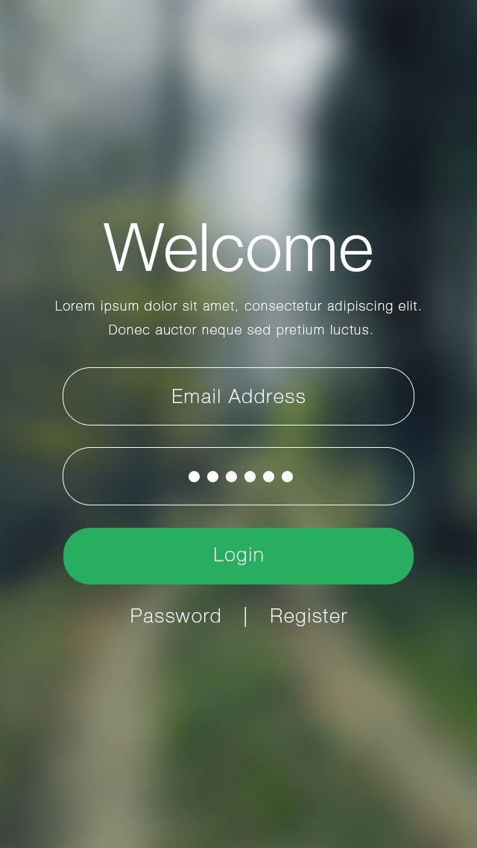

[This Photo](http://stackoverflow.com/questions/30022307/binding-a-web-pages-element-to-an-android-app) by Unknown Author is licensed under [CC BY-SA](https://creativecommons.org/licenses/by-sa/3.0/)

1. **Flexibility**

The multiplicity of ways the user and system exchange information.

**Dialog initiative:**

Client independence from fake imperatives on the info exchange forced by the framework.

**Multi-threading:**

The capacity of the framework to help client collaboration relating to more than one undertaking at a time. There are two sorts of multi-stringing as simultaneous and interleaved. In simultaneous sort, we contribution to numerous assignments at the same time. In interleaved type, moreover there are numerous errands, however contribution to each in turn.

**Task migratability**

Passing obligation regarding task execution among client and the framework. The client plays out the undertaking or have the PC play out the errands. In this horticulture data framework, the entered vegetable names/natural product names with missing spellings will auto right by the situation as a spellchecker.

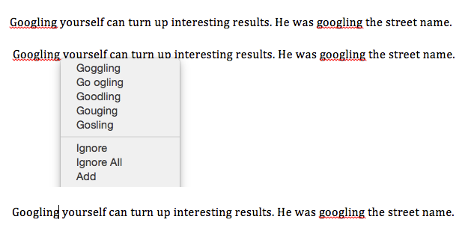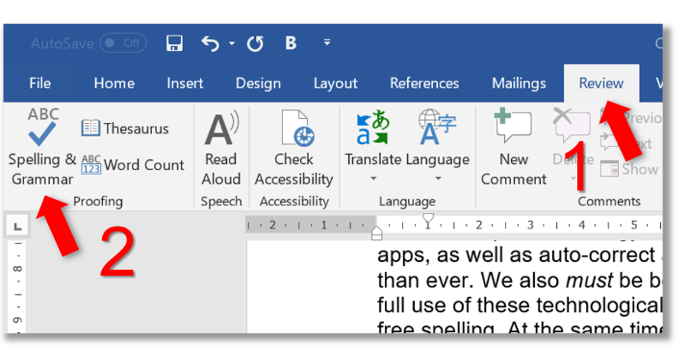

**Substitutivity:**

the degree to which an application permits comparable info and yield esteems to be fill in for one another (values in input e.g. Divisions/decimals, values in yield e.g. both advanced and simple, output/input e.g output can be reused as info)

**Customizability:**

The user can modify the interface in order to improve efficiency. The user can add commands or change font size for better visibility

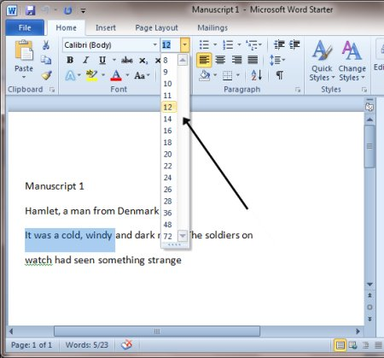

**3. Robustness**

The level of support provided to the user in determining successful achievement and assessment of goal-directed behavior.

**Observability:**

the extent to which the user can evaluate the internal state of the system from the representation on the user interface.

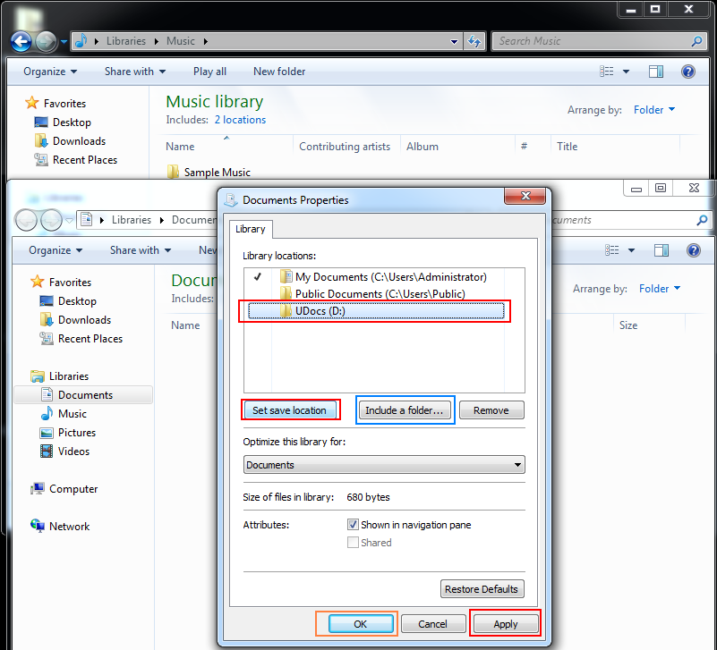

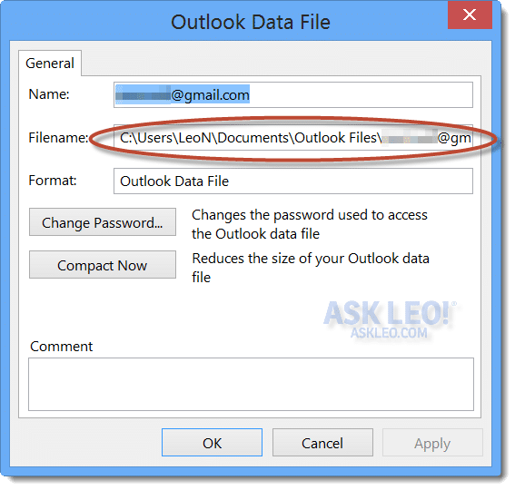

**Recoverability:**

the degree to which the client can arrive at the proposed objective after perceiving a blunder in the past collaboration.

In the event that the client needs to perceive what is in the following interface, for that reason there ought to be forward/next button.

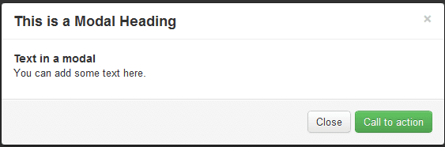

**Responsiveness:**

a proportion of the pace of correspondence between the client what's more, the framework.



